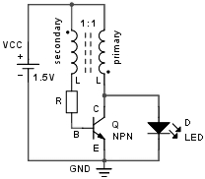**Joule Thief**

*(power a LED from a 1.2-1.5V battery)*

1. Let's start with the BJT OFF, no collector current flows, however, there is a base current through the transformer secondary which turns the BJT ON, at least somewhat.
2. The BJT turning ON brings the bottom side of the primary closer to GND, this almost constant voltage applied to the primary inductor produces a linearly rising current with slope (VCC – VCE) / L.
3. The change in current flowing out of the dot end of the primary induces VCC – VCE in the secondary (transformer windings ratio is 1:1). Because of the dot rule those VCC – VCE add up with the battery giving 2VCC – VCE between the bottom of the secondary and the emitter, the BJT goes into saturation.
4. The collector current continues to rise up to a maximum of β IB with IB = (2VCC – VCE – VBE) / R. In saturation we have IB = (3V – 0.2V – 0.6V) / R. When the collector current reaches its maximum, it stops rising, the voltage induced in the secondary drops to zero, and so the base current diminishes drastically, the BJT is practically OFF.

Note: some people erroneously claim that the collector current stops to rise because it levels off due to the inherent equivalent series resistance of the primary winding, or because the transformer core magnetically saturates.

1. Now that the BJT is almost OFF, the current in the primary inductor must flow somewhere, for this reason the primary inductor reverses its polarity and in series with the battery it feeds the LED with its current. There is also a voltage induced in the secondary with the base of the BJT more negative than the emitter: the BJT is now for sure completely OFF (see below warning).
2. The current from the primary inductor decreases and gets to 0, the magnetic field stops changing, the voltage in the secondary becomes 0 and we're back to when power was first applied.

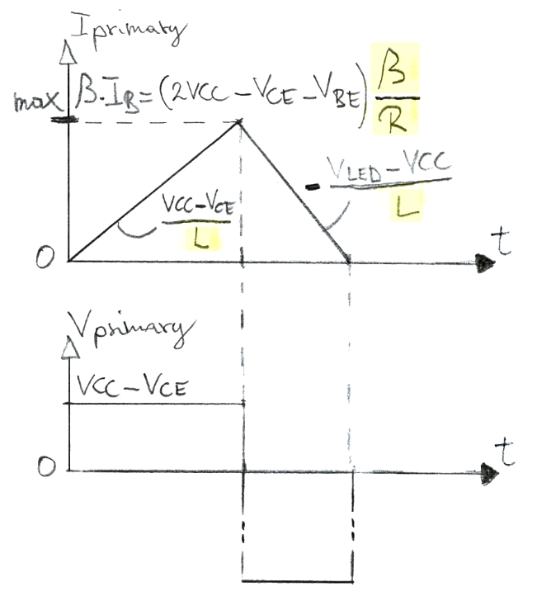

**Circuit design**

* Q: to waste less base current use a high β transistor (150 or more).
* R: from 1k – 50k.
* T: 10 – 100 turns with L: 33µH – 10mH.

**Warning**: when powering multiple LEDs in series or if no load is attached, add a diode (a 1N4148 with anode connected to emitter and cathode to base) that protects against the breakdown of the base-emitter junction. This diode may also be necessary when attaching the LED cathode to VCC instead of GND (a bigger voltage gets induced in the primary and thus also on the secondary).